**COMPILER DESIGN WEEK 3**

**Q. Design a lexical analyzer which contains getNextToken( ) for a simple C program to**

**create a structure of token each time and return, which includes row number, column**

**number and token type. The tokens to be identified are arithmetic operators, relational**

**operators, logical operators, special symbols, keywords, numerical constants, string**

**literals and identifiers. Also, getNextToken() should ignore all the tokens when**

**encountered inside single line or multiline comment or inside string literal. Preprocessor**

**directive should also be stripped.**

**Program:**

#include <stdio.h>

#include <stdlib.h>

#include <string.h>

#include <ctype.h>

struct token

{

char lexeme[64];

int row,col;

char type[20];

};

static int row=1,col=1;

char buf[2048];

const char specialsymbols[]={'?',';',':',',','.'};

const char *keywords[] = {"const", "bool", "char", "int","float", "double","unsigned", "return",

"for", "while", "do", "switch","if", "else","case", "break","printf", "continue"};

const char arithmeticsymbols[]={'*','%'};

int isKeyword(const char *str)

{

for(int i=0;i<sizeof(keywords)/sizeof(char*);i++)

{

if(strcmp(str,keywords[i])==0)

{

return 1;

}

}

return 0;

}

int charBelongsTo(int c,const char *arr)

{

int len;

if(arr==specialsymbols)

{

len=sizeof(specialsymbols)/sizeof(char);

}

else if(arr==arithmeticsymbols)

{

len=sizeof(arithmeticsymbols)/sizeof(char);

}

for(int i=0;i<len;i++)

{

if(c==arr[i])

{

return 1;

}

}

return 0;

}

void fillToken(struct token *tkn,char c,int row,int col, char *type)

{

tkn->row=row;

tkn->col=col;

strcpy(tkn->type,type);

tkn->lexeme[0]=c;

tkn->lexeme[1]='\0';

}

void newLine()

{

++row;

col=1;

}

struct token getNextToken(FILE *f1)

{

int c;

struct token tkn=

{

.row=-1

};

int gotToken=0;

while(!gotToken && (c=fgetc(f1))!=EOF)

{

if(charBelongsTo(c,specialsymbols))

{

fillToken(&tkn,c,row,col,"SS");

gotToken=1;

++col;

}

else if(charBelongsTo(c,arithmeticsymbols))

{

fillToken(&tkn,c,row,col,"ARITHMETIC OPERATOR");

gotToken=1;

++col;

}

else if(c=='(')

{

fillToken(&tkn,c,row,col,"LB");

gotToken=1;

++col;

}

else if(c==')')

{

fillToken(&tkn,c,row,col,"RB");

gotToken=1;

++col;

}

else if(c=='{')

{

fillToken(&tkn,c,row,col,"LC");

gotToken=1;

++col;

}

else if(c=='}')

{

fillToken(&tkn,c,row,col,"RC");

gotToken=1;

++col;

}

else if(c=='+')

{

int d=fgetc(f1);

if(d!='+')

{

fillToken(&tkn,c,row,col,"ARITHMETIC OPERATOR");

gotToken=1;

++col;

fseek(f1,-1,SEEK_CUR);

}

else

{

fillToken(&tkn,c,row,col,"UNARY OPERATOR");

strcpy(tkn.lexeme,"++");

gotToken=1;

col+=2;

}

}

else if(c=='-')

{

int d=fgetc(f1);

if(d!='-')

{

fillToken(&tkn,c,row,col,"ARITHMETIC OPERATOR");

gotToken=1;

++col;

fseek(f1,-1,SEEK_CUR);

}

else

{

fillToken(&tkn,c,row,col,"UNARY OPERATOR");

strcpy(tkn.lexeme,"--");

gotToken=1;

col+=2;

}

}

else if(c=='=')

{

int d=fgetc(f1);

if(d!='=')

{

fillToken(&tkn,c,row,col,"ASSIGNMENT OPERATOR");

gotToken=1;

++col;

fseek(f1,-1,SEEK_CUR);

}

else

{

fillToken(&tkn,c,row,col,"RELATIONAL OPERATOR");

strcpy(tkn.lexeme,"==");

gotToken=1;

col+=2;

}

}

else if(isdigit(c))

{

tkn.row=row;

tkn.col=col++;

tkn.lexeme[0]=c;

int k=1;

while((c=fgetc(f1))!=EOF && isdigit(c))

{

tkn.lexeme[k++]=c;

col++;

}

tkn.lexeme[k]='\0';

strcpy(tkn.type,"NUMBER");

gotToken=1;

fseek(f1,-1,SEEK_CUR);

}

else if(c == '#')

{

while((c = fgetc(f1)) != EOF && c != '\n');

newLine();

}

else if(c=='\n')

{

newLine();

c = fgetc(f1);

if(c == '#')

{

while((c = fgetc(f1)) != EOF && c != '\n');

newLine();

}

else if(c != EOF)

{

fseek(f1, -1, SEEK_CUR);

}

}

else if(isspace(c))

{

++col;

}

else if(isalpha(c)||c=='_')

{

tkn.row=row;

tkn.col=col++;

tkn.lexeme[0]=c;

int k=1;

while((c=fgetc(f1))!= EOF && isalnum(c))

{

tkn.lexeme[k++]=c;

++col;

}

tkn.lexeme[k]='\0';

if(isKeyword(tkn.lexeme))

{

strcpy(tkn.type,"KEYWORD");

}

else

{

strcpy(tkn.type,"IDENTIFIER");

}

gotToken=1;

fseek(f1,-1,SEEK_CUR);

}

else if(c=='/')

{

int d=fgetc(f1);

++col;

if(d=='/')

{

while((c=fgetc(f1))!= EOF && c!='\n')

{

++col;

}

if(c=='\n')

{

newLine();

}

}

else if(d=='*')

{

do

{

if(d=='\n')

{

newLine();

}

while((c==fgetc(f1))!= EOF && c!='*')

{

++col;

if(c=='\n')

{

newLine();

}

}

++col;

}while((d==fgetc(f1))!= EOF && d!='/' && (++col));

++col;

}

else

{

fillToken(&tkn,c,row,--col,"ARITHMETIC OPERATOR");

gotToken=1;

fseek(f1,-1,SEEK_CUR);

}

}

else if(c == '"')

{

tkn.row = row;

tkn.col = col;

strcpy(tkn.type, "STRING LITERAL");

int k = 1;

tkn.lexeme[0] = '"';

while((c = fgetc(f1)) != EOF && c != '"')

{

tkn.lexeme[k++] = c;

++col;

}

tkn.lexeme[k] = '"';

gotToken = 1;

}

else if(c == '<' || c == '>' || c == '!')

{

fillToken(&tkn, c, row, col, "RELATIONAL OPERATOR");

++col;

int d = fgetc(f1);

if(d == '=')

{

++col;

strcat(tkn.lexeme, "=");

}

else

{

if(c == '!')

{

strcpy(tkn.type, "LOGICAL OPERATOR");

}

fseek(f1, -1, SEEK_CUR);

}

gotToken = 1;

}

else if(c == '&' || c == '|')

{

int d = fgetc(f1);

if(c == d)

{

tkn.lexeme[0] = tkn.lexeme[1] = c;

tkn.lexeme[2] = '\0';

tkn.row = row;

tkn.col = col;

++col;

gotToken = 1;

strcpy(tkn.type, "LOGICAL OPERATOR");

}

else

{

fseek(f1, -1, SEEK_CUR);

}

++col;

}

else

{

++col;

}

}

return tkn;

}

int main()

{

FILE *f1=fopen("input.c","r");

if(f1==NULL)

{

printf("Invalid File\n");

return 0;

}

struct token tkn;

while((tkn=getNextToken(f1)).row!=-1)

{

printf("<%s, %d, %d, %s>\n",tkn.lexeme,tkn.row,tkn.col,tkn.type);

}

fclose(f1); }

**Output:**

input.c file:

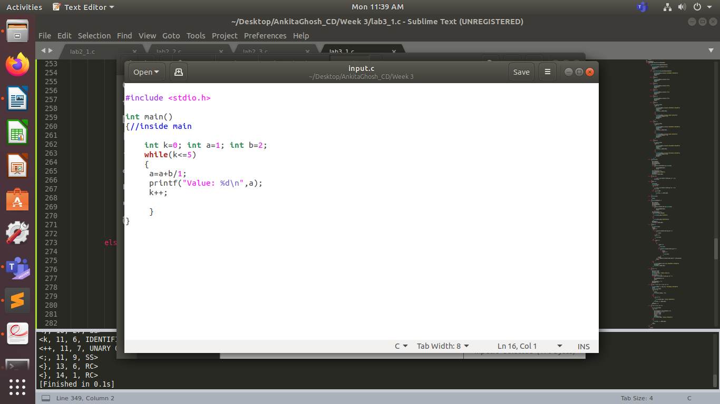

Terminal:

